Questionnaire

1. **Which is the reason of polarization of the transistor?**

A pole P will be polarized directly if it connects to the positive of the battery, the pole N will be polarized directly if it connects to the negative pole. The reverse they would be polarized inversely.

1. **What does us represent the β (thread) of the transistor?**

The base is physically located between the issuer and the collector and is composed of material semiconductor lightly doped and of high resistance.

1. **What does us represent the α (alpha) of the transistor?**

Often the value of in inverse way is minor to 0.5. The lack of symmetry is principally due to the rates of doping between the issuer and the collector.

1. **Which of the previous circuits is of polarization stable with the temperature?**

If we have a circuit of common seemingly stable issuer, with a point of definite functioning, it is possible to produce a great instability with an increase of temperature. This happens because on having increased the temperature the current of the collector is increased, though the base current remains constant

1. **It mentions what is the point of operation of the transistor**

The values of currents and tensions in it continues in the terminals of a transistor is named a point of work and is in the habit of expressing by the letter Q (Quiescent operating point).

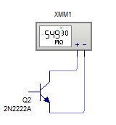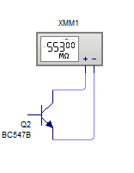Simulations



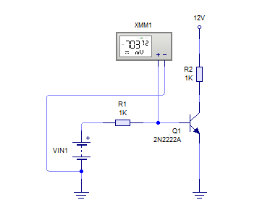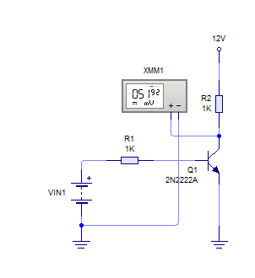

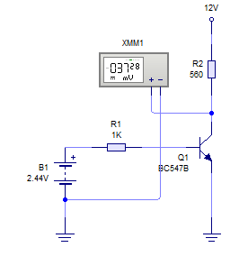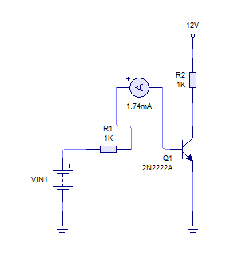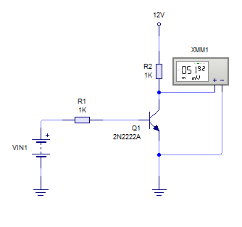

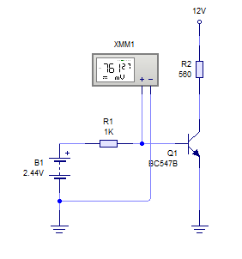

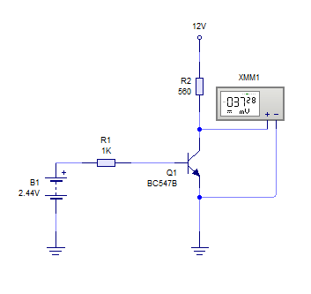

Circuito estabilizador en emisor

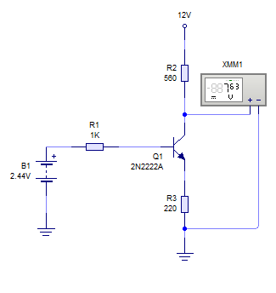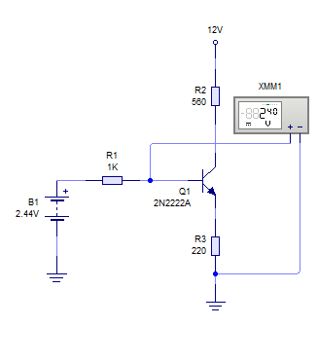

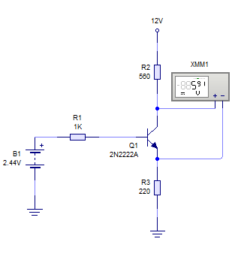

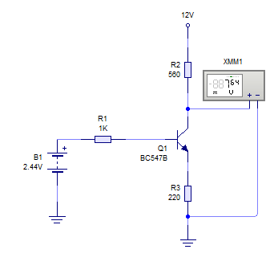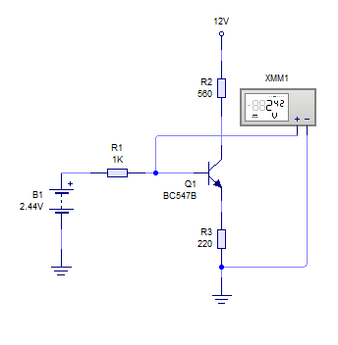

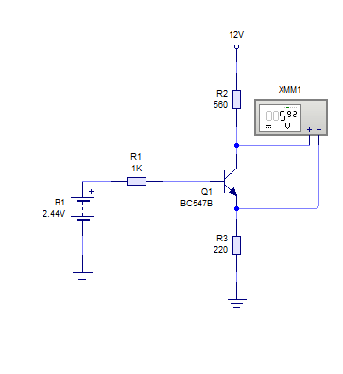

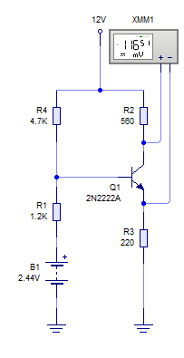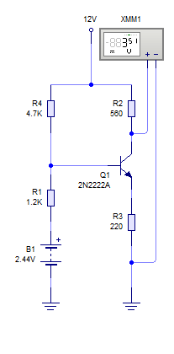Circuito por divisor de voltaje

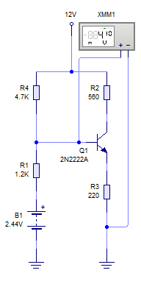

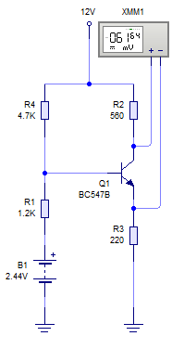

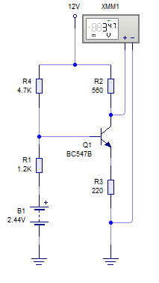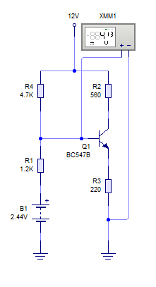

Transistor PNP

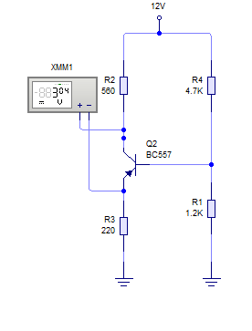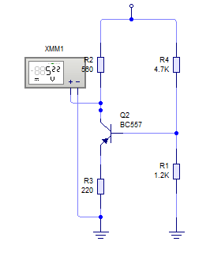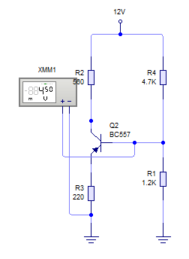

Conclusion

**Luciano Espina Melisa**

With practical this one, I have realized the importance of supporting a temperature in the circuits to the moment to use some transistor; in addition, it was possible to analyze every circuit with the different transistors and see how the thread and the alpha was reacting of each one.